# Installation and setup apikey.

After install this addon, you will see a popup alert for set your API before you can use it to scan your file.

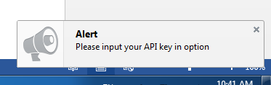

To obtain your free Metascan Online API key, please create an account or log into the [OPSWAT Portal](https://myportal.opswat.com/) and find the Metascan Online section under 'Licenses'. Expand this section to access your free Metascan Online API key.

After having APIkey, go to addon option and input your apikey.

* If you input an invalid apikey you will get an alert like the following image. You have to input a valid apikey before using this addon.



* If you input a valid apikey you will get an alert like the following image.



# Scanning a file

Right click on link download of a file you want to scan and select scan with metascan. Waiting some minute for add on download and upload the file you want to metascan and open a new page with scan result.

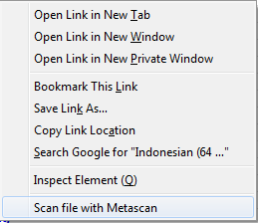

## View scan history

Click on the addon-icon to view your scan history